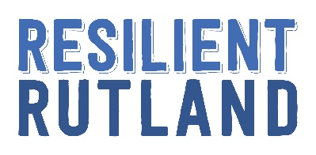

Self-Esteem: Helping Young People Find Purpose and Belonging

One in a series of webinars commissioned by Resilient Rutland to support
parents/carers and families.

What kind of role model do you want to be?
Our children are great imitators, so we should give them something great to imitate; but that can be easier said than done. To understand the impact of adult self-esteem on the developing self-esteem of children, it can help to cast our own minds back to childhood and try to recall how the adults around us spoke and acted. Whilst many would consider modesty to be a virtue, things can go too far the other way and adults, who are frequently very negative about themselves, teach children that this is an okay way to treat oneself…
- What do you think you role model well?
- What would you prefer your child did not copy?
- Who were your role models, good and bad, when it comes to self-esteem?
- How could you be a better role model – do you think it would make a difference?
- Fake it ‘til you make it; think about what you want your child to see.
- What positive role models could you highlight to your child – look for people like them.
- A simple place to start is ‘something I was proud of this week…’
In what ways are you a positive role model to your child?

What makes your child brilliant?
No doubt you can reel off a list of reasons why your child is simply fantastic. As a parent or carer, our love for our children tends to be deep and pure (on a good day!) and through an adult lens of love we’re able to see a whole range of things that make our child remarkable. Often we think and feel these things so deeply that we forget to celebrate them with our child and they have no idea of our admiration for their various skills, talents or characteristics and may not even realise that these things are worth celebrating in themselves.
- What stands out about your child to you – if you’re describing them to someone what do you say?
- Do you regularly tell your child what you admire about them (most parents don’t)?
- What would be an acceptable way that you can share how you feel with your child?
- Remember that physical tokens will often be kept (secretly treasured by some)
- Pay regular, meaningful compliments >spontaneous > specific >sincere
- Encourage your child to celebrate the positives in others and compliment them too.

What makes your child brilliant?

Multiple pillars of self-esteem
Multiple pillars make temples stronger… if we rest everything on one pillar then if that pillar were to crumble then the whole temple would fall down. I find this simple analogy a useful one for self-esteem. It’s true also that if too much rests on ‘one pillar of self-esteem’ then we leave ourselves at risk of everything crumbling around us. For example, children at football academies often eat, drink and sleep football. If they get injured or get dropped by the club then for some, their whole world falls apart because they have nothing left. So we need to help our children develop multiple pillars.
- Having deep, special interests is powerful, but we must have some other things we value about ourselves too
- This often happens with academics in the lead up to important exams, everything else fades
- For some children the one pillar is their looks, or their sport, or a particular hobby or friendship group
- For hobbies and interests that take up a lot of your child’s time, wonder ‘what if’ that were taken away – if it would feel catastrophic, that’s a worry
- Your child doesn’t have to be really good at something for it to be a pillar of their self-esteem, doing things because we enjoy the activity, or the people, makes for really solid pillars.
What makes up your child’s pillars of self-esteem?

Helping your teen to find their ikigai
Ikigai is a Japanese concept that means reason for being. Often used as a framework for adults looking to determine a fulfilling career, it can be a helpful framework for discussion and thought with your child too.
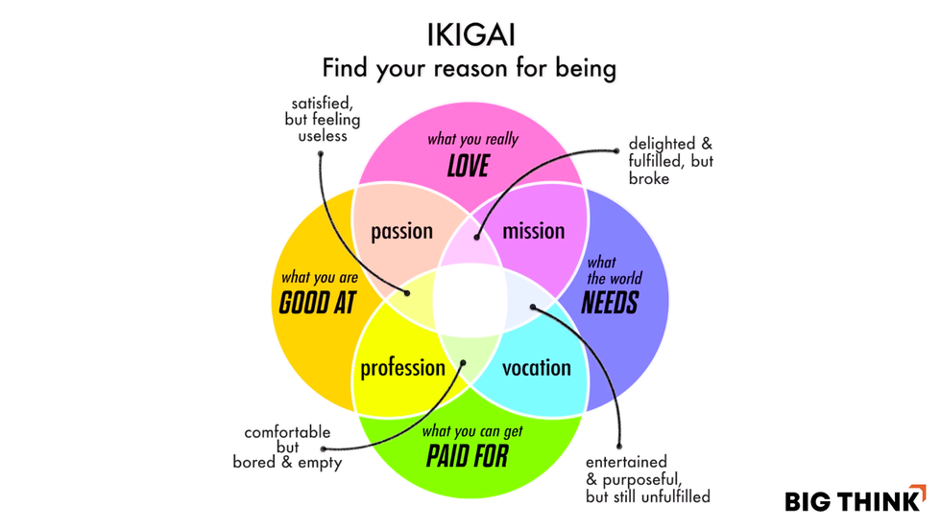
- What do you love? (passion)
- What are you good at? (profession)
- What does the world need? (mission)
- What can you get paid for? (vocation)

What’s your Ikigai? Would knowing it sooner have helped you?

the curse of perfectionism
We live in a time when perfectionism feels more and more the norm, whether it’s perfectionism about school work, looks, what we eat or any other domain of life you care to consider! The online world has created a situation where everyone curates their own personal brand and carefully airbrushed pictures and stories show the world their best side. The problem is that whilst we see the stories others choose to tell, we see our own life warts and all. And those warts can sometimes loom large. The strive for perfectionism can lead to wasted time, unrealistic expectations and a whole lot of heartache and misery too. Maybe good enough needs to be considered good enough again?
- What’s the mood music in your house, perfectionism or ‘good enough’ – are you happy with this?
- What are the benefits of perfectionism and unrelenting standards? Is there a place for them?
- At what point have things gone too far?
- What do we need to do to enable our child to adopt a ‘good enough’ attitude?
- Looking at our own life through the lens of others can help
- Asking why it matters what others think can be deeply instructive too.

Would your child consider themselves a perfectionist?

Learning to fail
One of the most important lessons an adult can teach a child is how to fail well. We learn so much from that which we don’t get right – but only if we approach these moments with curiosity and kindness to self. Think about a time you or your child have failed and what happened next. Was this a moment of learning, growth and perhaps a little laughter too or was this something to be quickly swept under the carpet and moved on form?
- What happens when we reframe failure ‘first attempt in learning’ or a ‘learning moment’?
- If we’re not failing, we’re not stepping outside our comfort zone.
- Do you role model a positive response to challenge and failure?
- Problem solving out loud is a helpful activity for children to observe
- Think about the skills your child needs to fail well - role model them and praise them
- Create safe spaces for sharing and celebrating failure – fail of the day
- Failure is often pretty funny… lean into laughter..
- Be there to help your child up if they stumble, but try to avoid walking for them.
When was the last time you failed? What would your child observe?

Finding a tribe
Finding the people with whom we fit is one of the things which brings us great pleasure in life and feeds into our sense of belonging, purpose and day to day happiness too. Helping your child to identify who their tribe might be and helping them to forge those early connections can be a real gift.
- Look to the pillars of self-esteem to find likely tribes
- You don’t have to be like each other to like each other – but there is usually a thread that holds you together (an experience, proximity, a person in common).
- Investing time in people and groups pays dividends. Consider how you can support your child to develop positive friendships and group belonging – acting as host or taxi is often enough!
- The world is small now - your child can find people like them online if not offline
- Not all tribes are positive but there is always something positive in it for the child so be wary of putting your foot down too firm or too fast; empathy will often get you farther.
What tribes are you part of? How did you find one another?

Aiming low to fly high
We are often taught to aim high – if we reach for the moon and we miss then we land amongst the stars. But… this comes with a lot of pressure, whether it’s internal pressure from a child aiming high for themselves or external pressure from the adults around them. Sometimes this weight of expectation can feel almost crippling and can hold a child back from realising their potential or enjoying the journey. Instead, I often find that we are able to reach far giddier heights when we aim low and build a continuous cycle of self-improvement using ‘I Can’ cycles. Each time we find we can do something, we are motivated to try the next step. Each step feels small and achievable and there is never too far to fall.
- It can help to have an idea of the eventual goal – but beware pinning too many hopes on impossible feeling futures
- Small steps are more manageable and you land with less of a bump if you miss one
- Goals are most likely to be achieved when your child is involved in setting them
- Consider your role here… cheer leader, guide..
- When your goals and your child’s don’t align, be curious and remember, it is their life!
- Your child will often reach highest for and by themselves, but may need to learn what’s possible
- When in doubt, do the next right thing

What are your child’s goals? Do they know the next step?

Connect with Pooky
You can connect with Pooky on Twitter, YouTube, Instagram, Facebook or LinkedIn. You may also be interested in the books she has authored, edited or contributed to and her podcast.

On-demand training / speaking requests
You can see all our on demand courses here (the free ones are here) and our free resources and webinars are here. To book a tailored walkthrough of our website and to get your whole staff team 4 weeks’ free access to trial the site, you can book a slot with me here. For bespoke speaking or training enquiries, you can book a chat with me here.

